CSA1717-ARTIFICIAL INTELLIGENCE
PRACTICAL LAB EXPERIMENTS
RAGAVI S – (192565027)

EXPERIMENT 2: 8-QUEEN PROBLEM
Aim
The aim of this experiment is to solve the 8-Queens Problem using the Backtracking algorithm by placing eight queens on an 8 × 8 chessboard such that no two queens attack each other.
Objective
To place queens safely without any overlaps on rows, columns, or diagonals.
Algorithm
Step 1: Start in the top row (Row 0) of the chessboard.
Step 2: For the current row, try placing a queen in the first available column (Column 0 to 7).
Step 3: Check if this column position is safe. It is safe if no other previously placed queen shares the same column, left diagonal, or right diagonal.
Step 4: If the position is safe, place the queen at this position and recursively move to the next row (Row + 1) to place the next queen.
Step 5: If all 8 queens are successfully placed across all 8 rows, stop and print the final board configuration.
Step 6: If the position is not safe, or if the recursive path leads to a dead-end where no queen can be placed in the next row, remove the queen from the current position (backtrack).
Step 7: Try the next column in the current row. If all columns in the current row have been tried and none work, backtrack to the previous row and move that queen to its next column.
Source Code
def is_safe(board, row, col):
# Check column and both diagonals against previous rows
for i in range(row):
if board[i] == col or \
board[i] - i == col - row or \
board[i] + i == col + row:
return False
return True

def solve_queens(row, board):
if row == 8: # Goal reached for all 8 rows
return board
for col in range(8):
if is_safe(board, row, col):
board[row] = col
result = solve_queens(row + 1, board)
if result: return result # Bubble up the first found solution
return None

# --- Run and Print 1st Solution ---
solution = solve_queens(0, [0]*8)

if solution:
print("--- 8-Queens Solution ---")
for col in solution:
row_str = ["."] * 8
row_str[col] = "Q"
print(" ".join(row_str))

Flowchart
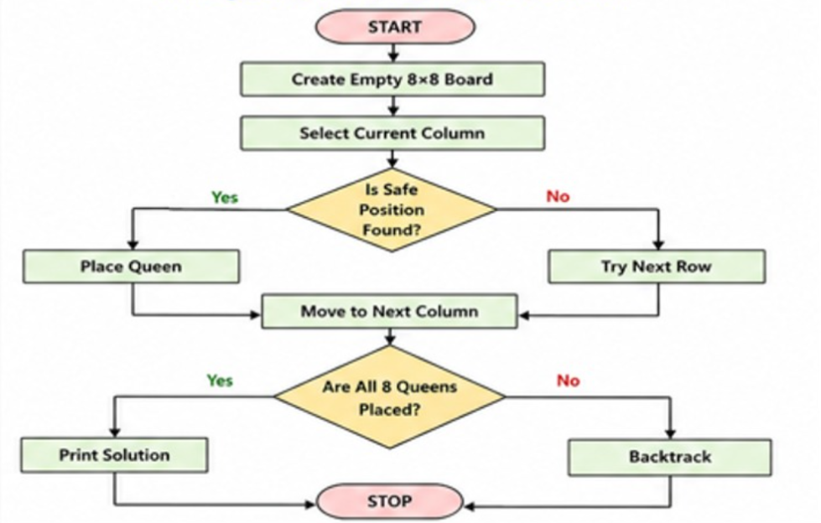
Output
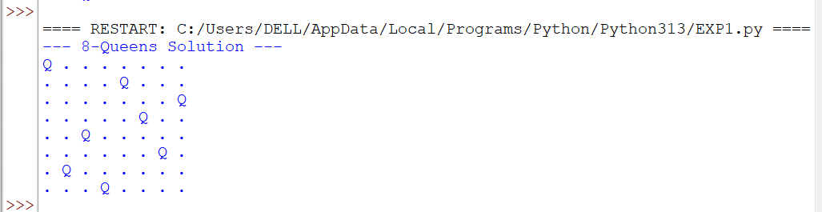
Result
The 8-Queens problem was successfully solved using the Backtracking algorithm by finding a valid chessboard configuration where no two queens attack each other.

